Tim Blockchain

Alfan Olivan

Bagus Rezky Adhyaksa

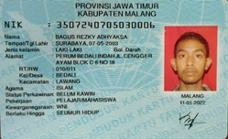

Muhammad ‘Ali Murrofid

Mochammad Zaky Zamroni

Bagus Dwi Putranto

